Gear System Hand Calculations
Assumptions
- At least 6 teeth must be engaged with the belt at all times (N_{engaged}>6)
- The gear ratio should be lower than 5:1
- Timing belt transmits torque instantaneously; thus pinion torque is a function of driven gear torque and gear ratio
- Driven gear is modeled as cylinder for inertia calculations
- LiDAR unit is modeled as shaft for inertia calculations
Diagram
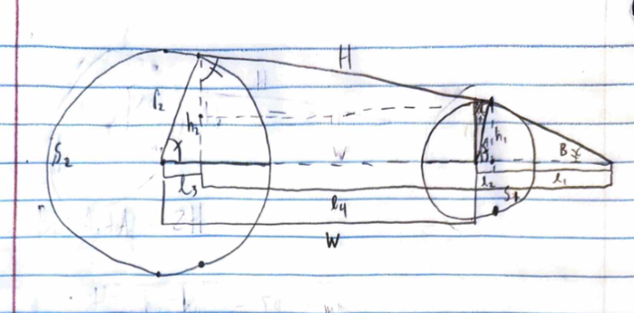
Figure J1. Hand Sketch of Gear Geometry

Calculations
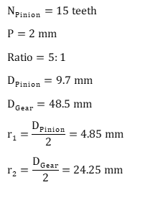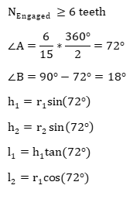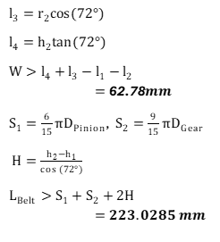

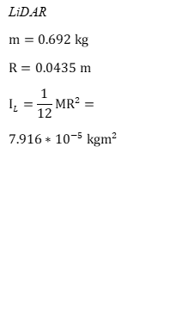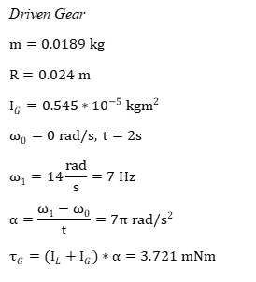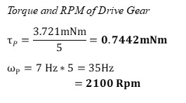s

